fed 5b by Red Army Camera
June 18th, 2011
http://www.theclickshop.net/products/fed-5b/

Vintage FED 5B soviet era rangefinder!

Availability:
Fed 5B Black
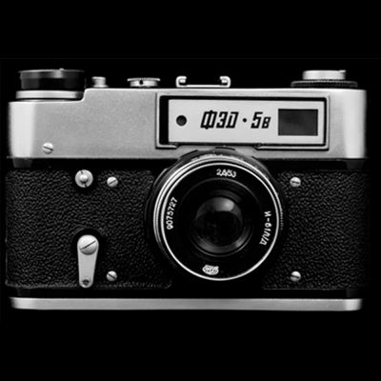
Fed 5B Red
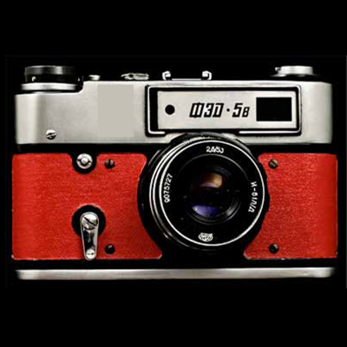
Fed 5B Neon Pink
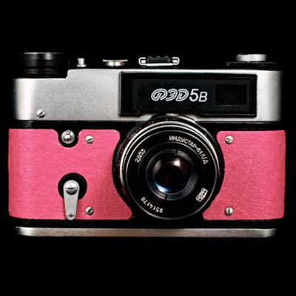
Fed 5B Hohloma
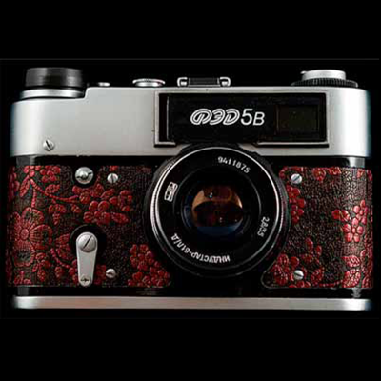
Fed 5B Denim
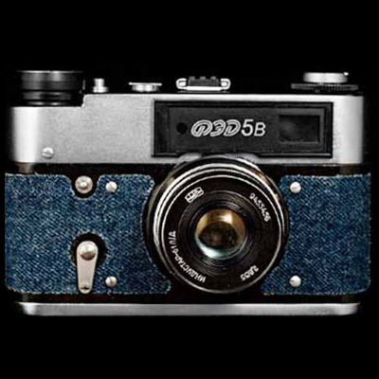
Fed 5B Metalic
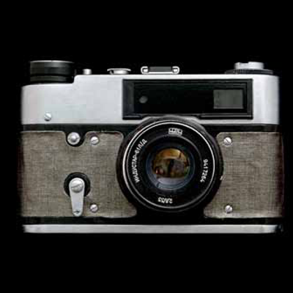

Artist Series fed 5b: artist series
August 18th, 2011
These vintage Soviet-era rangefinders are tested to work and refurbished by Red Army Camera. All these vintage cameras are unused so they are ALL in mint condition. You are NOT buying used (2nd hand) vintage cameras.
ps: If you like vintage cameras and you like art, you will appreciate these!

FED 5B Russian Revolution limited edition
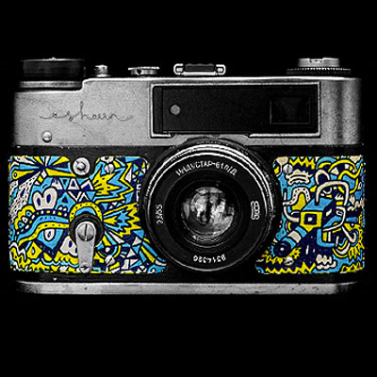
FED 5B Russian Revolution designed by Eeshaun
eshaun (b. 1980) is a self-taught Singaporean artist and illustrator. His automatic paintings and drawings are experiments in abstraction, humour and improvisation, resulting in the creation of non-linear, open-ended narratives that could either meet with success or complete failure – a process that he find quite enjoyable. Since starting gardensilly in 2005, he has created artworks and illustrations for Adidas, Nike, The Discovery Channel, onedotzero (UK), FARM, Nicholas, The Singapore Fashion Festival 2006, Play Imaginative, Zouk, IdN, Pictoplasma and the San Diego Comic Conference. eeshaun is also an Asian Kinetic Artist for Tiger Translate 2007, and was also recently featured in 20/20 BASE, an exhibition celebrating 20 of Singapore’s most creative talents, under the Singapore Design Festival 2007. In 2008, he was commissioned with FARMWORK, Designact and RE:act by Design Council Singapore as curatorial leads to design the Singapore Pavilion, ‘Singapore Supergarden’, for the prestigious 11th Venice Architectural Biennale. His largest public art installation, ‘Move!’, comprises three murals at the Bishan Circle Line, was commissioned by the Land Transport Authority of Singapore and unveiled in 2009. He teaches at the School of Technology for the Arts in Republic Polytechnic, Singapore.

FED 5B Darbotz “Monster”
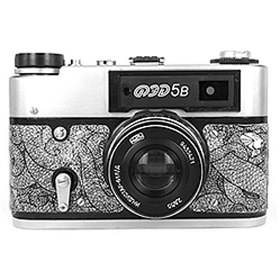
FED 5B Darbotz “Monster” designed by Darbotz
Darbotz loves Jakarta very much. For him, the traffic jam, the chaos and the hecticness of Jakarta must be faced by him everyday. That which bring out his visual character of his work. The cumi (squid). A character describes his alter ego in facing the hard city.
Darbotz first signature on the street probably his school gang name back in 1997, from walls, buses, and including at the enemy schools area. After more comprehend visual principles during lectures in 2000-2004, darbotz develop in efforts to create visual characteristics as his own identity, which is shall be recognized without putting his name in the drawing. Unlike graffiti which showing your street name with typography, he explored how to make identity without using any typography. Influenced by hiphop culture with Wu Tang Clan, NWA, A Tribe Called Quest on his tapes he explored and actually able to reconcile himself with the situation of Jakarta urban society which represented by him. Darbotz find alter ego that also reflects the situation of the city that he faces everyday.
He began to make his character on the street in 2004, the character itself always evolve, its like the dynamic of urban society, always evolve. He also one of the founder of Tembokbomber.com, one of the biggest street art and graffiti community in Indonesia.
His visualization style is very distinctive and unique. Darbotz solely uses black and white and a bit of accentuation. This is part of strategy that he uses when work on the streets. Black and white becomes the cure of urban festive colors with a variety of advertising products such as billboards, neon box, and city lights. By using simple color, the picture that he made in the wall able to take the attention in the middle of visual density. Besides working on the street, works of darbotz also attract the attention of some big companies to cooperate. Nike, Google chrome and other companies use darbotz’s work to collaborate. Moreover, darbotz also produce clothing and merchandise product with character that he developed. Through this way the darbotz character transformed in various media as the same citizen who spread and become part of urban culture.
That style was also applied on canvas. Darbotz assume that both patterns that he applies on canvas or on the street are the same. Energy expended, the ideas presented, as well as the techniques applied. But darbotz admits that there are different challenges in each of them. Canvas has a smaller medium, whitle on the street, according to darbotz, there is no space limit, not locked, we can smell the sense on the street, pollution, wind, traffic jams, the sound of cars passing by, and the rest is the same.

FED 5B OSN limited edition
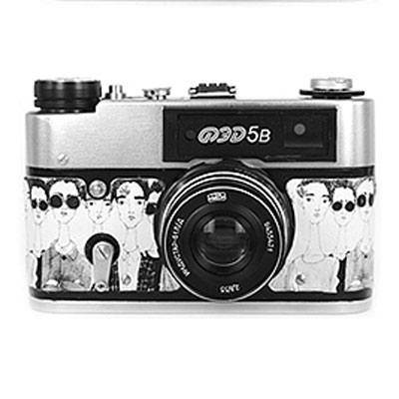
FED 5B OSN designed by ONESIXTYNOTEPAD
ONESIXTYNOTEPAD is a style journal that was founded in 2007. The blog has progressed since its formative years and now covers a breadth of topics ranging from runway trends to Streetstyle. Administered by three lads from different backgrounds, the blog embodies their common interest in anything remotely fashionable. With a candid name derived from the price of a notepad, one is sure to read tongue-in-cheek critique and waggish reviews.

FED 5B Cheeeese! limited edition

FED 5B Cheeeese! designed by Gersonewone
Gersonewone’s works mainly express emotions and inspiring moments or objects that caught his attention and pour it straight into any kind of experimental art form. Spent most of his life and education in Jakarta, Indonesia and with a background in graffiti, street art and pop culture, Gersonewone has been at it since 2006, using aerosol, stickers, canvas and all kinds of medium. He was awarded ‘best new comer’ in Tembok Bomber, an Indonesian Street Art Community. He won the Gold Award in illustration for Crowbar Awards in 2009, ASEAN grant Awards in 2010 and graduated from Nanyang Academy of Fine arts majoring in Illustration Design, 2011. Clients he has worked with includes NOISE Singapore, NIXON, Kult 3D, Tiger Translate and he was featured in MODE Magazine Singapore recently.

FED 5B Iron Snail limited edition
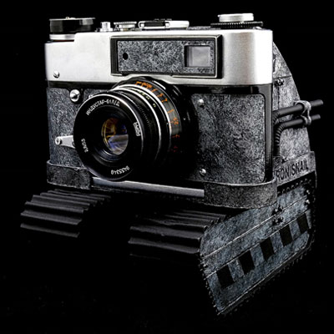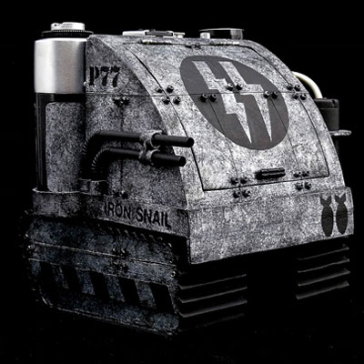
FED 5B Iron Snail designed by Phu
The name Phuek or Phu in short is a self-created lingo. Entirely imaginative and not based upon adherence to actuality. 3D art is his pursuit, especially in vinyl customizing. Phu’s Phuturistic concept is a manifestation through his artistic form of thought and personalized treatment in which he exercises the habit of recycling. And it’s with this Phuturistic niche, Phu’s customed vinyls have been commissioned and showcased in various international exhibitions and shows worldwide.

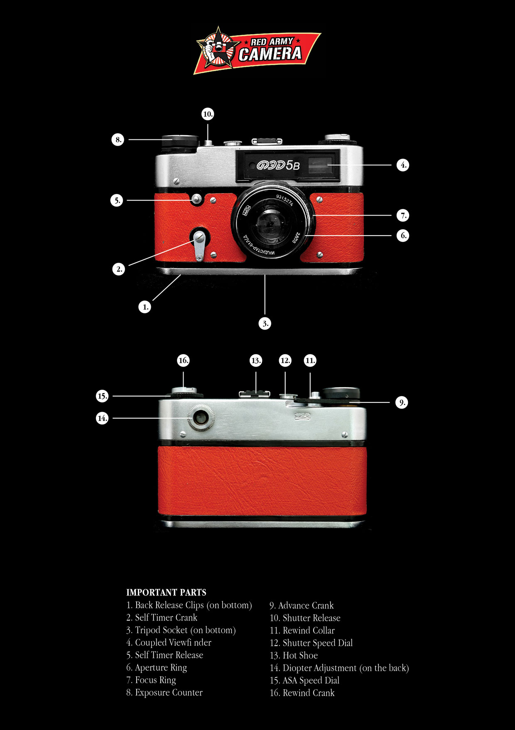

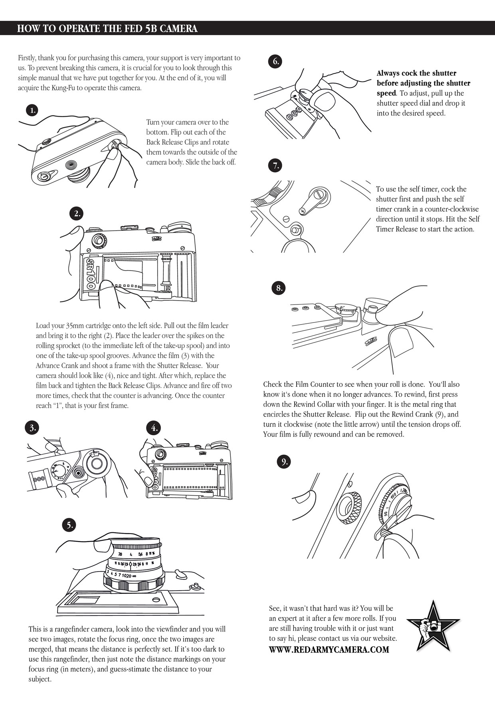

xxxxxxxxxxxxxxxxxxxxxxxxxxx

